**How to Build a Leg Loop Harness for Activity Loggers**

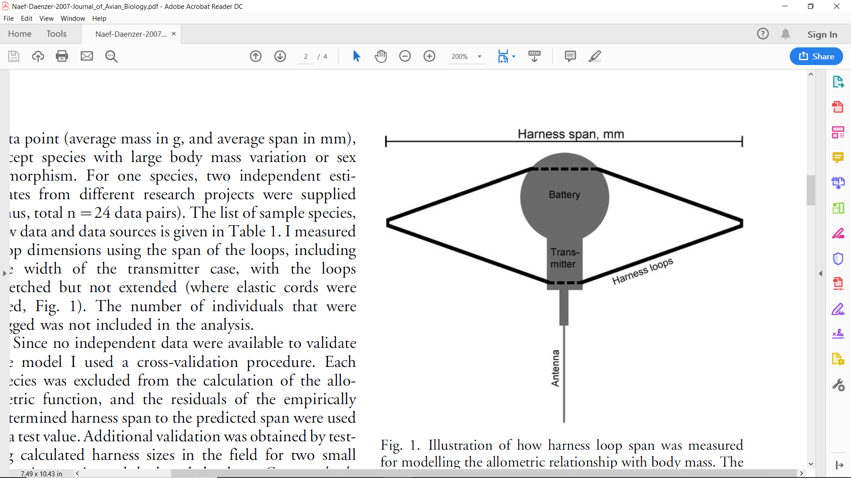

* **Fig 1 from (Naef-Daenzer et. al 2007)**

**Thanks to the Computer Science Department at IU, we have been able to utilize newly developed activity loggers to study animal behavior. This guide will demonstrate the method to build a harness for use on birds. For a reliable formula to size for birds please see “An allometric function to fit leg-loop harnesses to terrestrial birds” by Beat Naef-Daenzer. This paper has proven to be very effective for ornithologists seeking to apply harness based data trackers/transmitters. For application of loggers, an individual with the proper permits and training will need to be found or trained by someone with previous experience.**

**Step 1: Materials**

* First, you’ll need to gather your materials
* Six Thumbtacks
* Elastic bead cord 1mm (can be obtained at any arts and crafts store)
* Small scissors or a razor blade (needs to be sharp to cut string)
* Nail Polish (to glue knots together) or super glue
* White paint marker or sharpie (to mark the string)
* Ruler
* A corkboard
* An Ultralightweight Activity Logger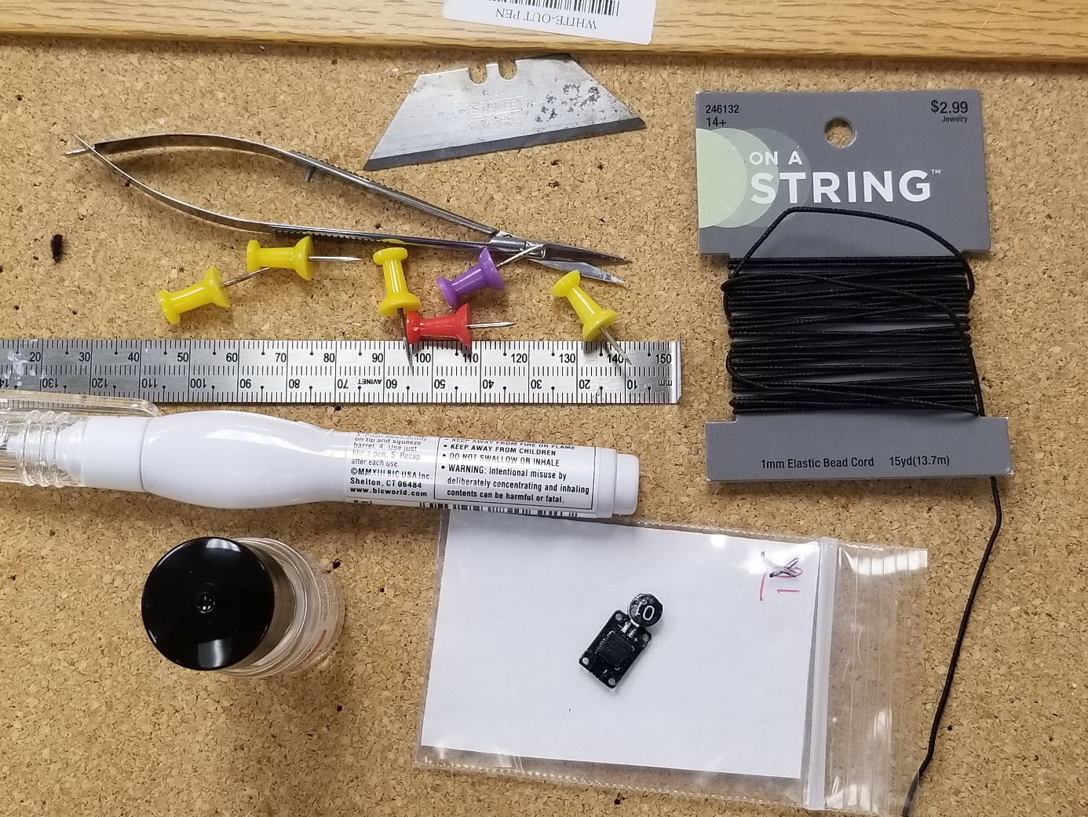

**Step 2: Begin Building**

* Begin with a size in mind, you will not be able to measure until later in the process however(On Juncos we commonly use 42-44mm)
* Put the string through a hole on the opposite side of the battery (the battery is the circular part hanging off with the tag number!)
* Put string through and leave about double the length of your desired size. So, for 40mm loggers, leave 80mm
* Make sure that the string does not go over the side with the gold dots! These will face down onto the bird’s back

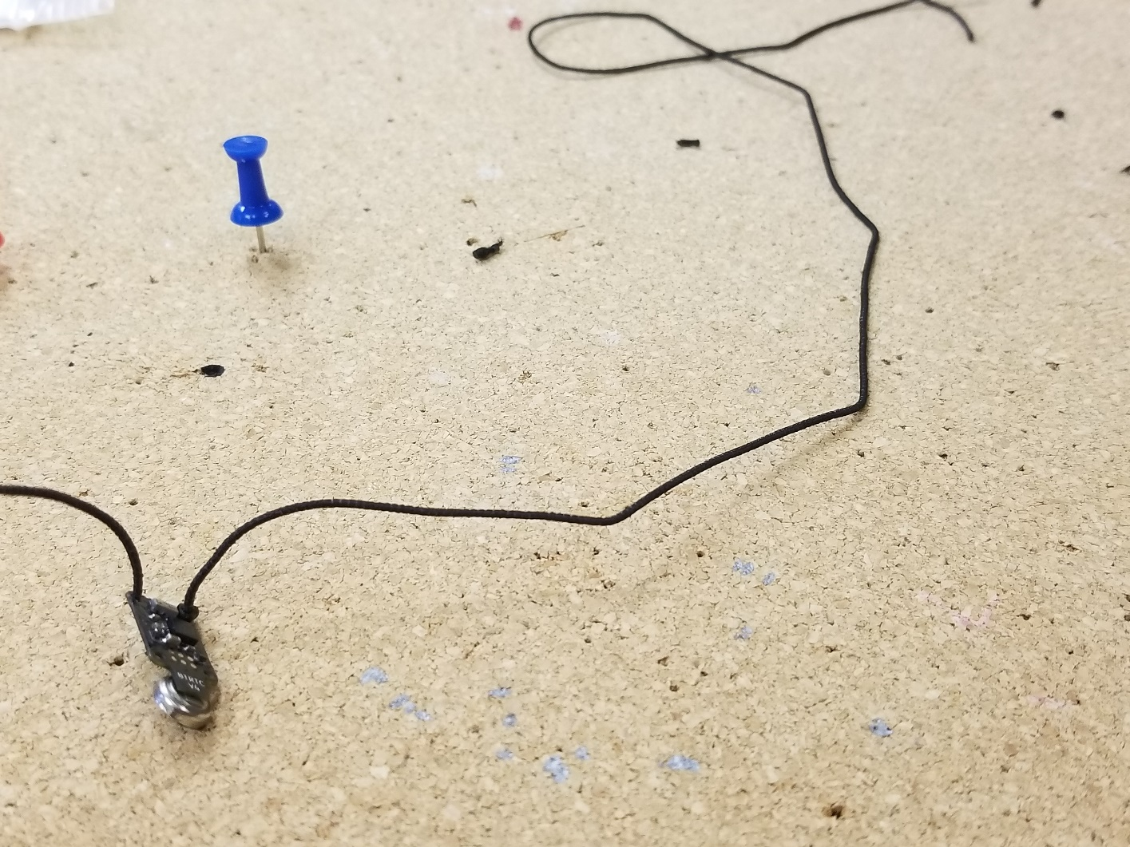

**Step three: Safety Knot!**

* Tie a knot at the base of the second hole that you will put the string through. Make sure you still leave plenty of string!
* Make sure it is set up so that the knot will stay at the base
* To make charging easiest, again check that the knot is not on the side with the gold dots! Shown below in the picture

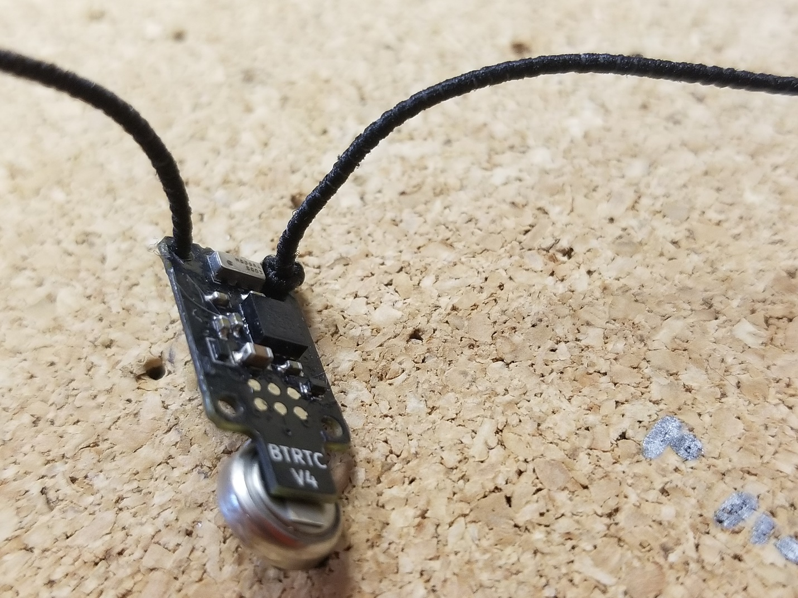

* As you can see the knot is not on the side with the gold dot

**Step Four: Put through rest of holes**

* Put the string through the rest of the holes so that two loops can be made (shown below)

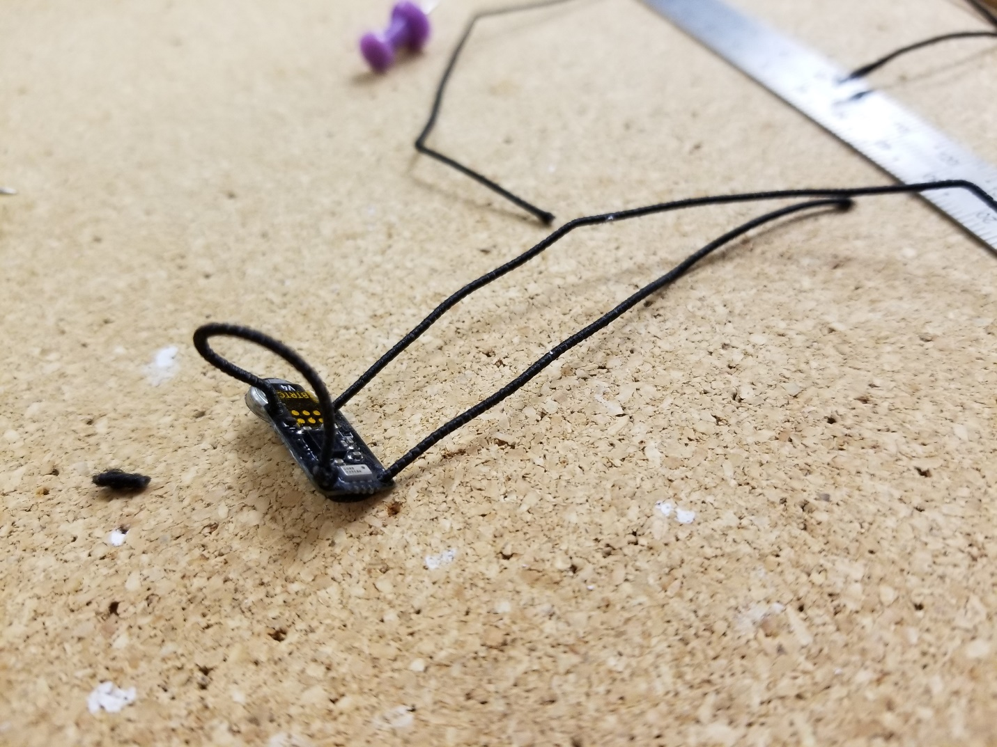

**Step 5: Measure Your Tag**

* You should have measurements in mind before you start building a harness
* However, you will only be able to get an accurate measurement of harness size at this step
* Take two thumbtacks and place them so that their distance is your desired size
* Place the logger around the two thumbtacks, I have it measured below for about 43 mm
* 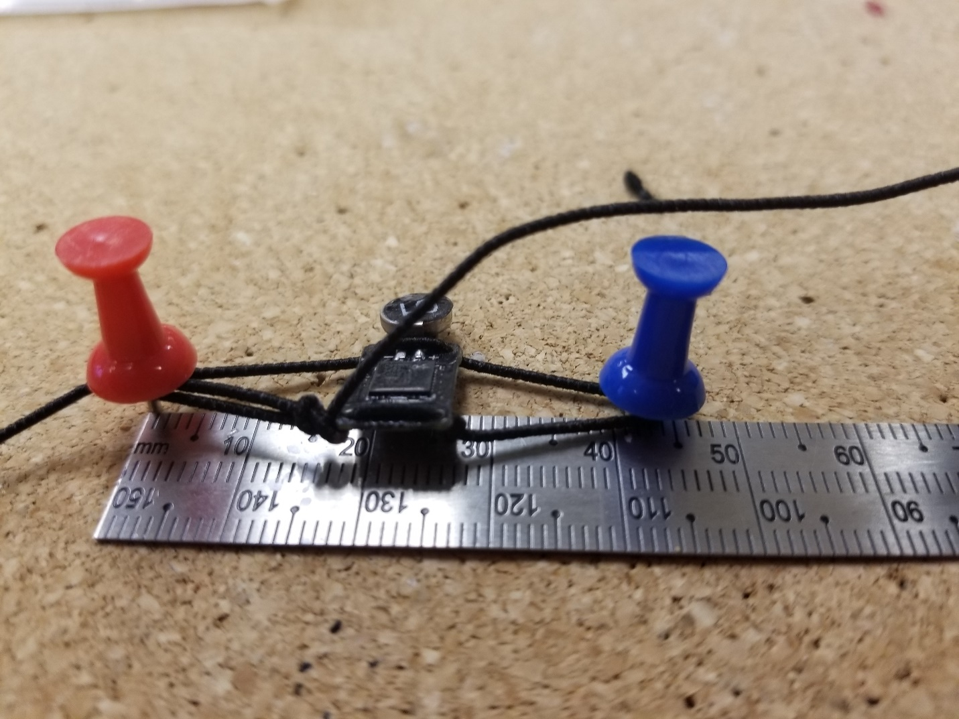It’s important to note that the logger is not holding itself together yet! I am holding the untied portion taught to estimate my desired size

**Step 6: Use paint marker to mark your string**

* Holding the harness tight but not too tight, make a mark on the strings so that a knot may be tied on the base of the left side of the logger as shown below
* Again, make sure to not have the string too tight (if the thumbtacks are being pulled off the board, it’s too tight

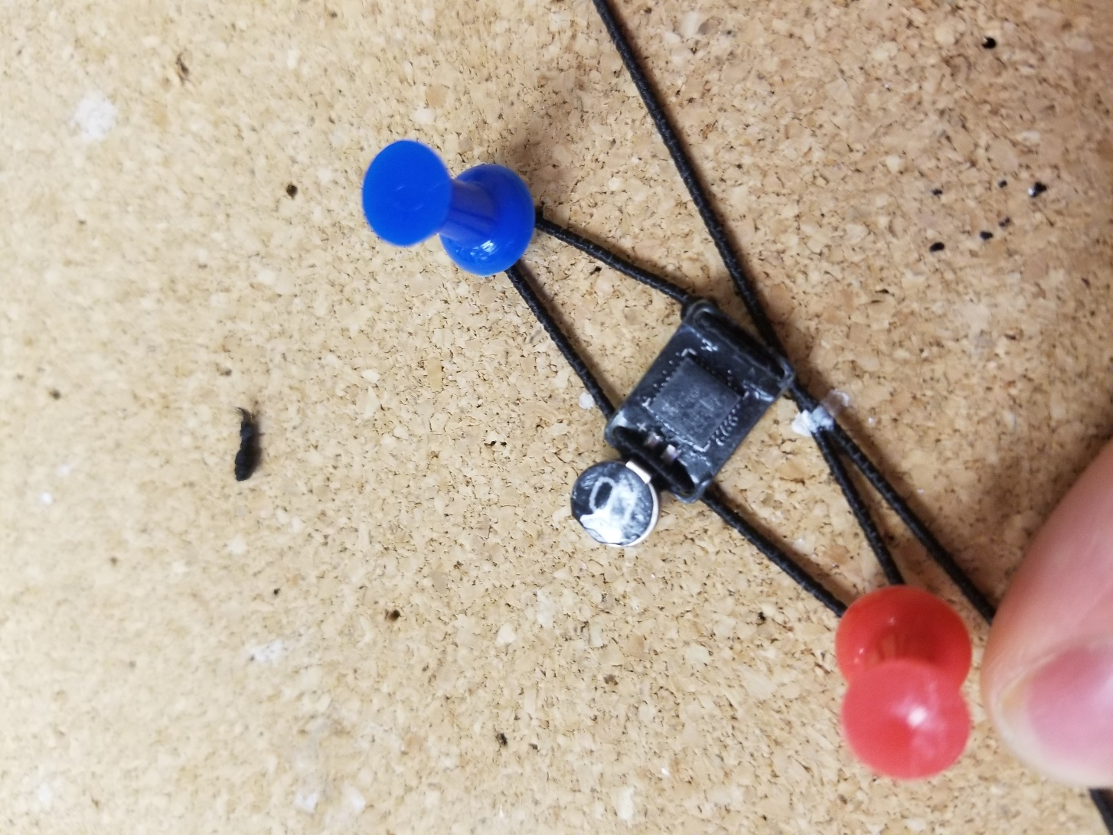

**Step 7: After marking the string, tie a knot so that it sits at the base of the logger**

* Use the white marks to line up the knot to the size you had measured (there will be some estimation involved but you can always refer to your tacks
* The knots should be tied so that they will stay at the base of the logger (notice the tape, that will need to be applied over the gold dots after charging)
* Make sure to check your size, once you have tightened the knot and cut the extra strings

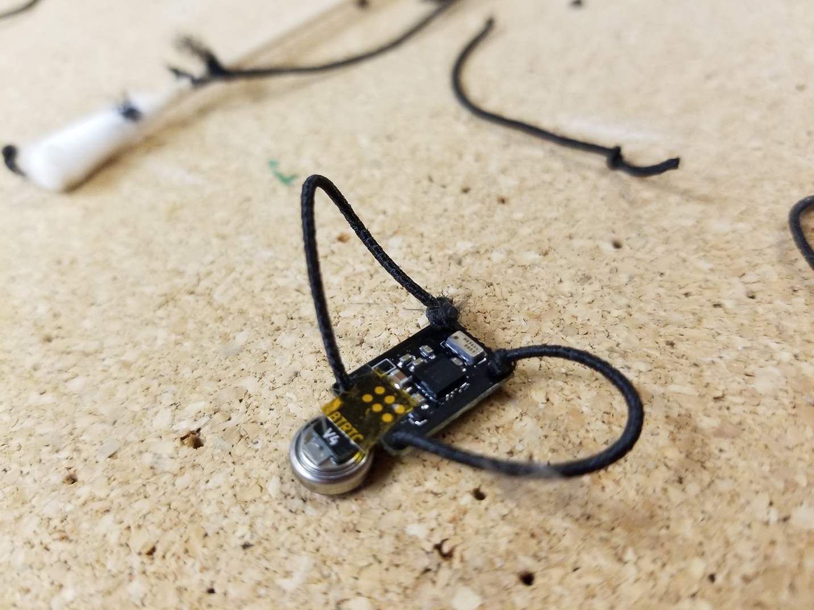

**Step 8: Apply Nail polish to the Knots**

* Apply nail polish to the knots as shown below so that the knots will hold
* It will dry and function as glue (it is also optional to use super glue)
* Try not to use so much that it gets on the rest of the logger

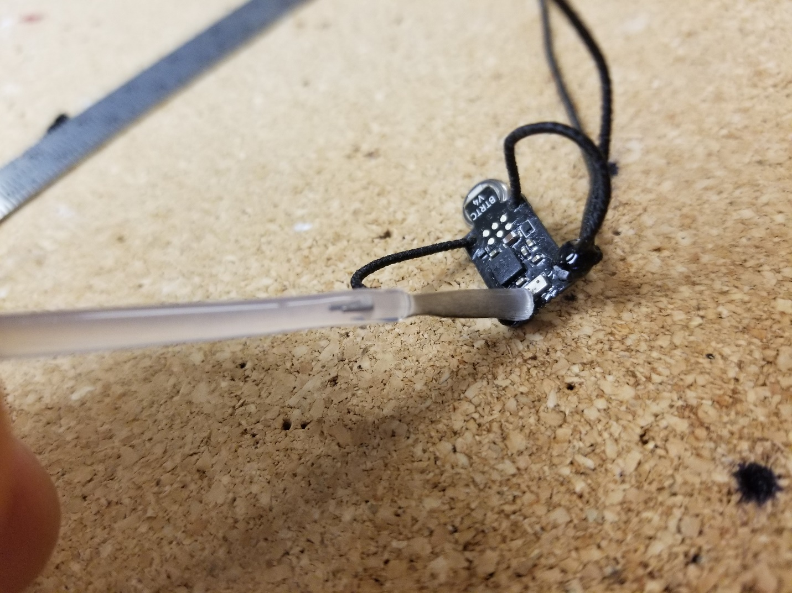

**Step 9: Admire your work**

* Congratulations! You have finished
* You can refer to your tacks one last time to make sure that your measurements have been accurate

